The Friends of the Glen Rock Library

2018 CHILDREN’S
ALLSTAR READATHON
A fundraiser benefitting the Glen Rock Public Library
Thursday, March 1 – Saturday, March 31
★★★★★★★★★★★★★★★★★★★★★★★★★★★★★★★★★★★★★★★★★★★★★★★★★★★★

Participants To-Do List
- Fill out the top half of the form accurately, legibly and completely
- Sign up at least one sponsor
- Read your books during the month of March and record all minutes read in and out of school
- Show your reading log to your sponsor(s) before April 20th and collect your pledge money
- Have your parent/guardian sign the form after the Readathon concludes
- Turn in your entry sheet with checks in at the Glen Rock Library or at your school by Friday, April 20th
- Receive your medal at your school or at the library in early June

AllStar Reader Medals
In order to receive a medal and be counted towards the school, grade total and special recognition, you must:
- have a parent/guardian signature on the form to certify that the minutes read are accurate
- include a pledge with a minimum of $5 contributed
- read in and out of school combined a minimum of:
★ Preschool: 150 minutes total reading time (about 5 minutes per day)
★ Kindergarten and Grade 1: 300 minutes total reading time (about 10 minutes per day)
★ Grade 2 and 3: 450 minutes total reading time (about 15 minutes per day)
★ Grade 4 and 5: 600 minutes total reading time (about 20 minutes per day)

Special Town Recognition Categories
★ Gold Level Reader(s) in each grade
must meet the goal of 4,500 minutes read
★ Most money raised by an individual/family
★ School with the highest participation
Special School Recognition Categories
★ Silver Level Reader(s) in each grade
must meet the goal of 3,600 minutes read
★ Grade with the highest participation

The Friends of the Glen Rock Public Library host the annual Readathon to encourage children to read and to use the library. The Readathon also raises funds for Children’s Room materials, programs and services, such as computers, software, audio visual supplies, guest artists and storytellers. The popular library summer reading program is fully funded by funds raised through the Readathon. If you have questions, please stop by or call the Library Children’s Room (201-670-3973). To find out more about the Friends of the Glen Rock Public Library, check us out at glenrocklibrary.org/friends-of-the-library.

AllStar Reader Information
Please complete all information. Circle school and grade.
First Name: Last Name: male female
Phone Number: | Total minutes read:
Email address: | Total $ received:
Pre-K Kindergarten 1st 2nd 3rd 4th 5th
Central Byrd Hamilton AOOL Coleman Other:

AllStar Sponsors
Sponsors may pledge a single amount or per minute read. Please, no door-to-door solicitation. Make all checks payable to the “Friends of the Glen Rock Public Library”. No cash, please! Sponsors’ contributions are tax-deductible; a sponsor’s canceled check is his or her receipt. If a sponsor’s gift is eligible for a corporate matching program, please include the company’s matching gift form. Please include additional sponsors on the back.
AllStar Sponsor’s Name | Pledge  Per Minute | Single Pledge | Total  Received
Grand Total Received |  |  | $

AllStar Reading Log
(log all minutes read per day in school, at home, in the car….) – Gold Level > 4500 min; Silver level > 3600 min
March Total: | Week 1 |  | Week 2 |  | Week 3 |  | Week 4 |  | Week 5
Monday |  |  | 5 |  | 12 |  | 19 |  | 26
Tuesday |  |  | 6 |  | 13 |  | 20 |  | 27
Wednesday |  |  | 7 |  | 14 |  | 21 |  | 28
Thursday | 1 |  | 8 |  | 15 |  | 22 |  | 29
Friday | 2 |  | 9 |  | 16 |  | 23 |  | 30
Saturday | 3 |  | 10 |  | 17 |  | 24 |  | 31
Sunday | 4 |  | 11 |  | 18 |  | 25
Total per week

___________________________________________________________ __________________
Parent/Guardian Signature Date
I certify that the minutes read by the Readathon participant above are accurate and that he/she is allowed to participate in the 2018 Readathon Fundraiser.

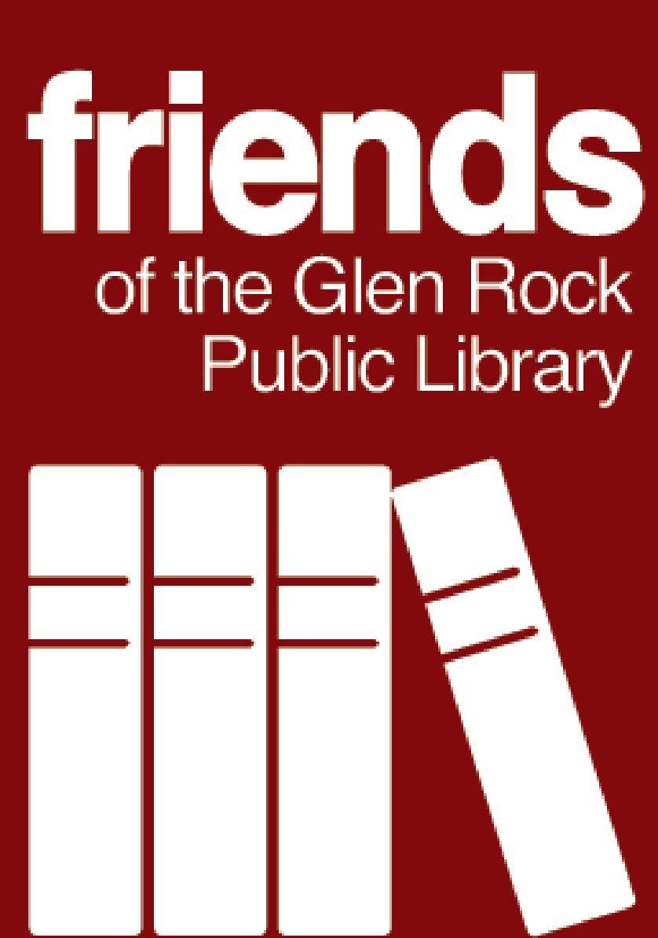
Friends of the Glen Rock Public Library, 315 Rock Road, Glen Rock, NJ 07452
glenrocklibrary.org/friends-of-the-library / friends@glenrocklibrary.org
Be the first to know what’s new with us. Follow the Friends on and .

